**Application: Drozer**

Drozer is an android application security testing framework developed by FSecureLABS that makes it easy for a tester to create test cases and check for possible vulnerabilities in the components of an application. It was formerly known as Mercury and has honorable mentions in much leading mobile application security testing books as well. It is the de-facto standard for android application security testing frameworks.

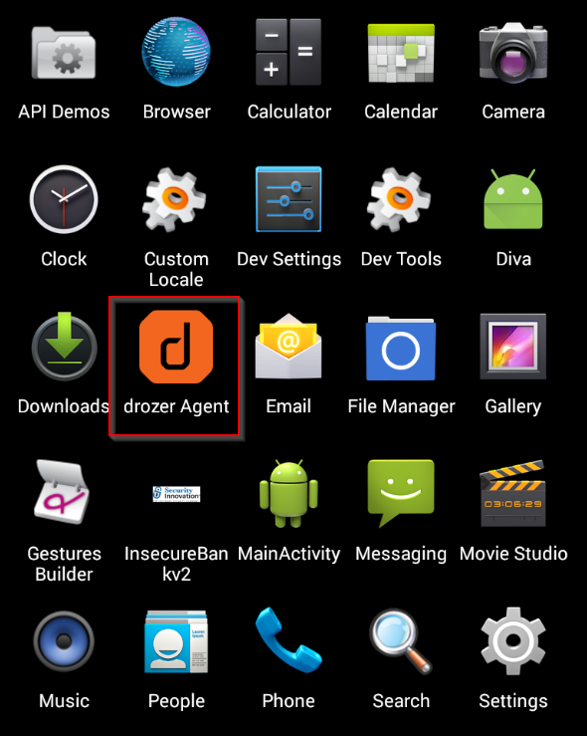

Drozer Application use port 31415

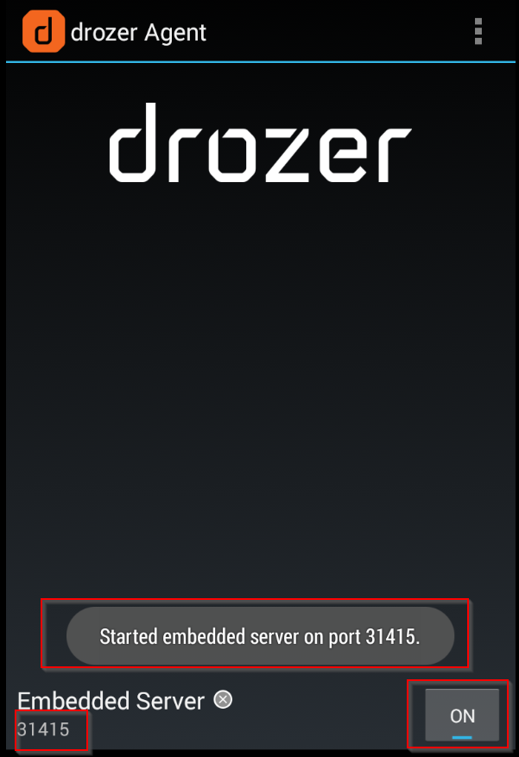

We have to connect Drozer server at port number 31415

**Code**: adb forward tcp:31415 tcp:31415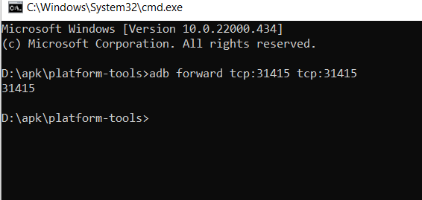

To connect Drozer console

**Code**: drozer console connect

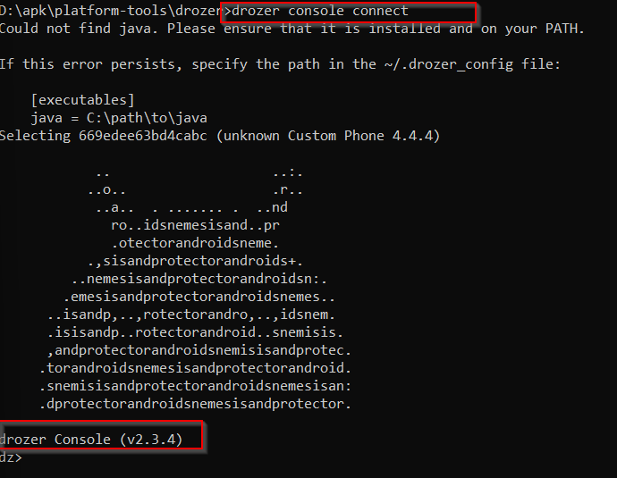

**list** command is used to available activity we can perform on application

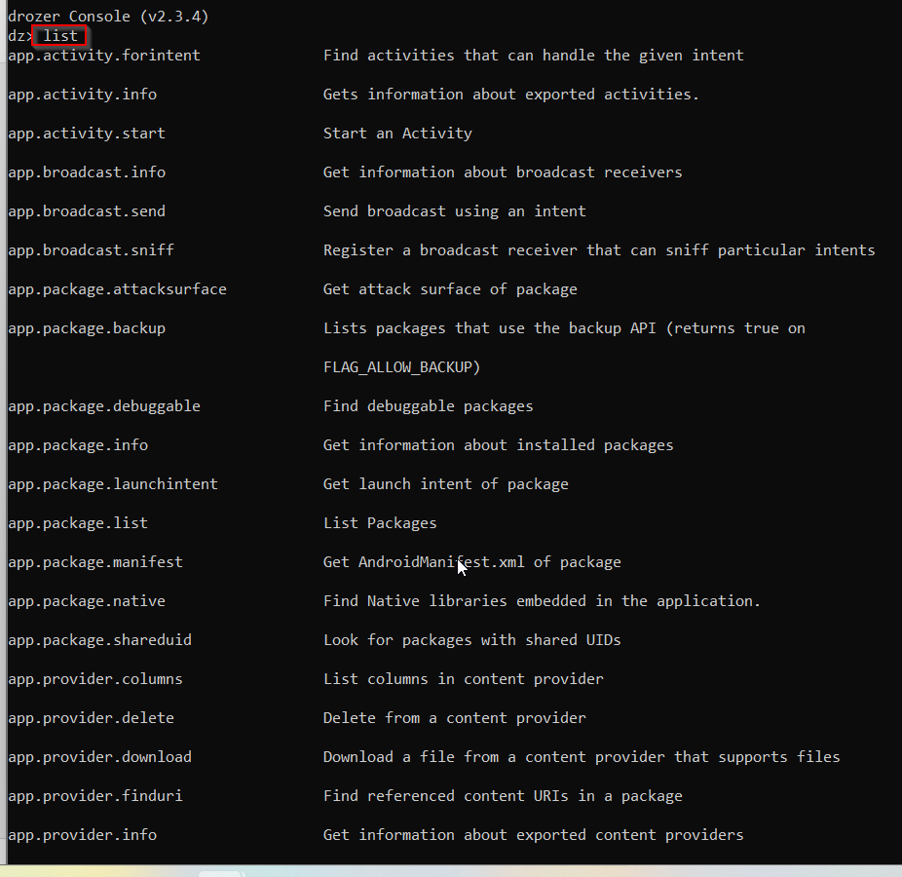

1.Gets information about installed packages.

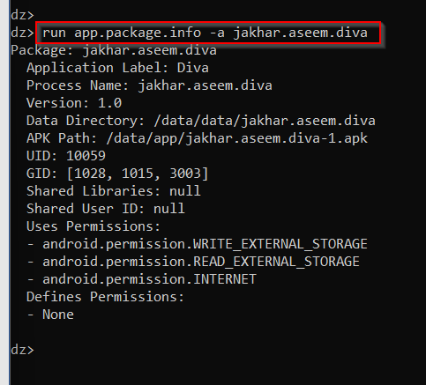**Code**: run app.package.info -a jakhar.aseem.diva

2. Get AndroidManifest.xml of package

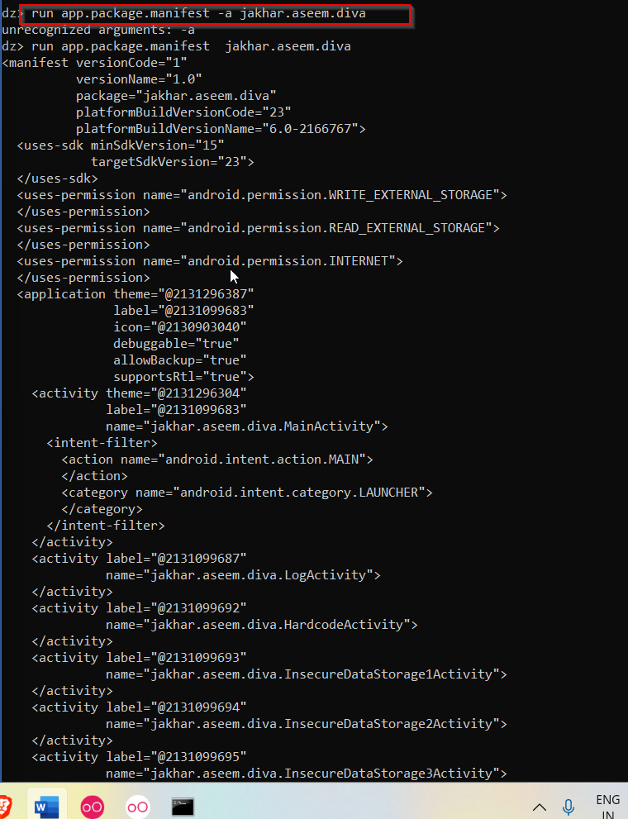**Code**: run app.package.manifest jakhar.aseem.diva

3. Get attack surface of package

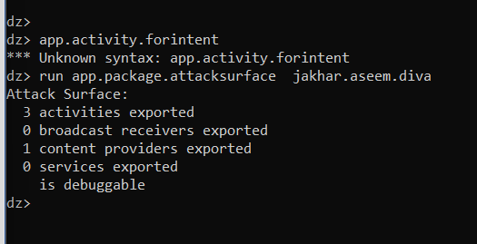**Code**: run app.package.attacksurface jakhar.aseem.diva

4. Gets information about exported activities.

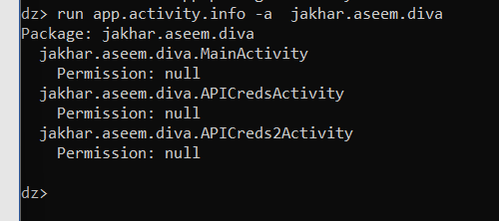**Code**: run app.activity.info -a jakhar.aseem.diva

5. Get information about exported content providers

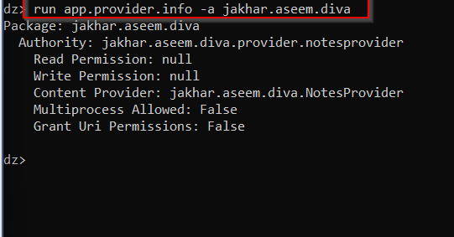**Code**: run app.provider.info -a jakhar.aseem.diva

6. Find referenced content URIs in a package

**Code**: run scanner.provider.finduris -a jakhar.aseem.diva

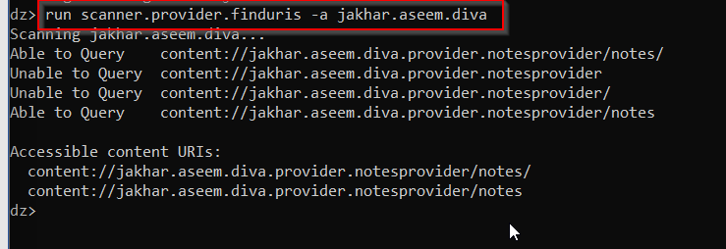

7. Test content providers for SQL injection vulnerabilities.

**Code**: run scanner.provider.injection -a jakhar.aseem.diva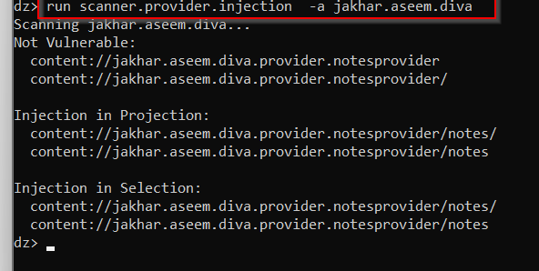

8. Find tables accessible through SQL injection vulnerabilities.

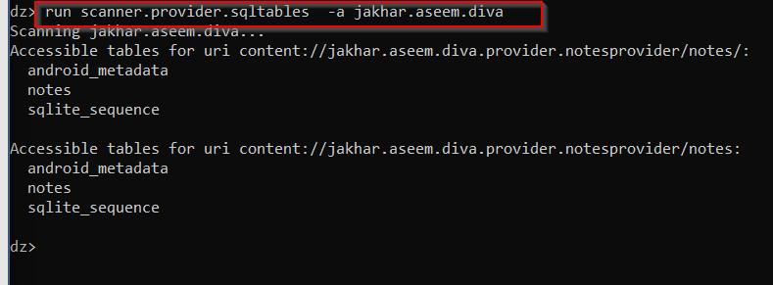**Code**: run scanner.provider.sqltables -a jakhar.aseem.diva

9 Test content providers for basic directory traversal

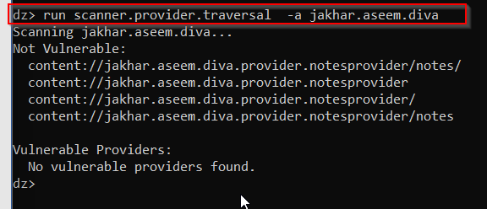**Code**: run scanner.provider.traversal -a jakhar.aseem.diva

10. Print Date/Time

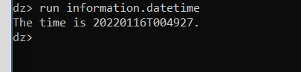**Code**: run information.datetime